**Verification of Superposition Theorem**

**Name: Adwait S Purao**

**UID:** 2021300101

**Branch:** Computer Engineering

**Batch:** B2

**CIRCUIT DIAGRAM:**

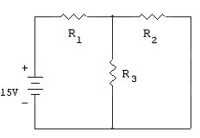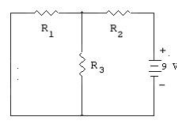

**Figure 1 Figure 2**

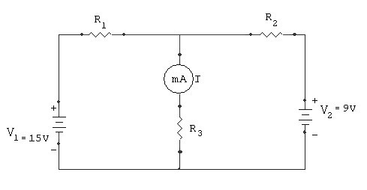

**Figure 3**

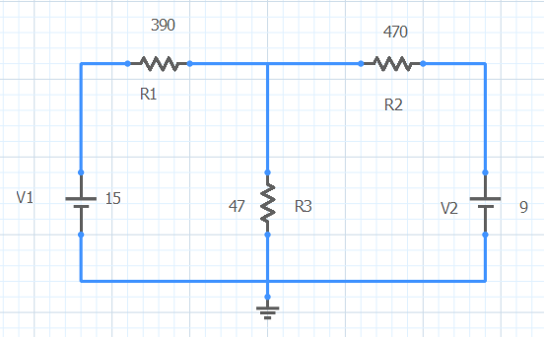

**Sequel Implementation**

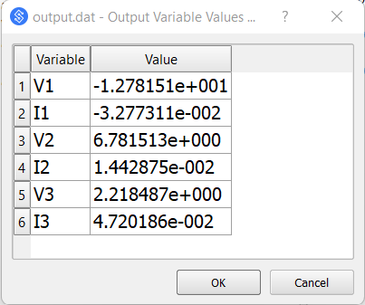

**Sequel Output**

**OBSERVATION TABLE:**

**R1 = 390 , R2 = 470 , R3 = 47**

|  |  |  |  |  |
| --- | --- | --- | --- | --- |
| **V1 (V)** | **V2 (V)** | **Current through**  **R1 (A)** | **Current through**  **R2 (A)** | **Current through**  **R3 (A)** |
| **15** | **-** | -0.032 | -0.0032 | 0.031 |
| **-** | **9** | 0.002 | 0.017 | 0.016 |
| **15** | **9** | -0.03 | 0.014 | 0.047 |

**EXPERIMENT No: 2 DATE: 30 / 5 / 2022**

# **Verification of Superposition Theorem**

**AIM:** To verify Superposition theorem using circuit implementation on breadboard and using simulator.

**APPARATUS & COMPONENTS REQUIRED:**

Resistors (values), Power supply(rating), DMM, connecting wires, breadboard, Sequel Simulator

**THEORY: Write theory related with following questions.**

1. Define linear, bilateral, active element
2. Write statement of Superposition theorem.

**PROCEDUCE:**

1. Connect the circuit as shown in the circuit diagram.
2. Apply voltage V1=15V and remove voltage V2 and short the path.
3. Note down the current reading through R1, R2 and R3 due to voltage source V1=15V.
4. Now remove V1 and replace it by short path. Connect V2=9V and measure the current through R1, R2 and R3 due to V2=9V
5. 5) Again, connect both the supply V1=15V and V2=9V and measure the current through R1, R2 and R3.
6. Find the theoretical reading of current through R1, R2 and R3 using superposition theorem and verify it with the practical reading.
7. Repeat steps 2 to 6 by changing the voltage V1 and V2.
8. Implement the given circuit using Sequel simulator.
9. Simulate the circuit, find currents, and verify them with theoretical values.

**Linear elements:** These are elements in which the constituent relation, the relation between voltage and current, is a [linear function](https://en.wikipedia.org/wiki/Linear_function). They obey the [superposition principle](https://en.wikipedia.org/wiki/Superposition_principle).

Examples of linear elements are resistances, capacitances, inductances, and linear dependent sources.

**Bilateral elements:** Bilateral elements are defined as the elements through which magnitude of current is independent of polarity of supply voltage. This means, the V-I characteristics of such type of element does not get affected by the polarity of voltage.  A [resistor](https://electricalbaba.com/resistance/), [inductor](https://electricalbaba.com/concept-of-self-inductance/), [capacitors](https://electricalbaba.com/why-do-capacitor-block-dc-but-allows-ac/) are example of bilateral circuit elements.

**Active element:** An active element is an element capable of generating electrical energy. The essential role of this active element is to magnify an input signal to yield a significantly larger output signal.

**Superposition theorem** : The superposition theorem is a derived result of the [superposition principle](https://en.wikipedia.org/wiki/Superposition_principle) suited to the [network analysis](https://en.wikipedia.org/wiki/Network_analysis_(electrical_circuits)) of [electrical circuits](https://en.wikipedia.org/wiki/Electrical_network). The superposition theorem states that for a [linear system](https://en.wikipedia.org/wiki/Linear_system) (notably including the subcategory of [time-invariant linear systems](https://en.wikipedia.org/wiki/Linear_time-invariant_system)) the response ([voltage](https://en.wikipedia.org/wiki/Voltage) or [current](https://en.wikipedia.org/wiki/Electric_current)) in any branch of a bilateral [linear circuit](https://en.wikipedia.org/wiki/Linear_circuit) having more than one independent source equals the algebraic sum of the responses caused by each independent source acting alone, where all the other independent sources are replaced by their internal impedances.

To ascertain the contribution of each individual source, all of the other sources first must be "turned off" (set to zero) by:

* Replacing all other independent voltage sources with a short circuit (thereby eliminating difference of potential i.e. V=0; internal impedance of ideal voltage source is zero (short circuit)).
* Replacing all other independent current sources with an open circuit (thereby eliminating current i.e. I=0; internal impedance of ideal current source is infinite (open circuit)).

**CALCULATION:**

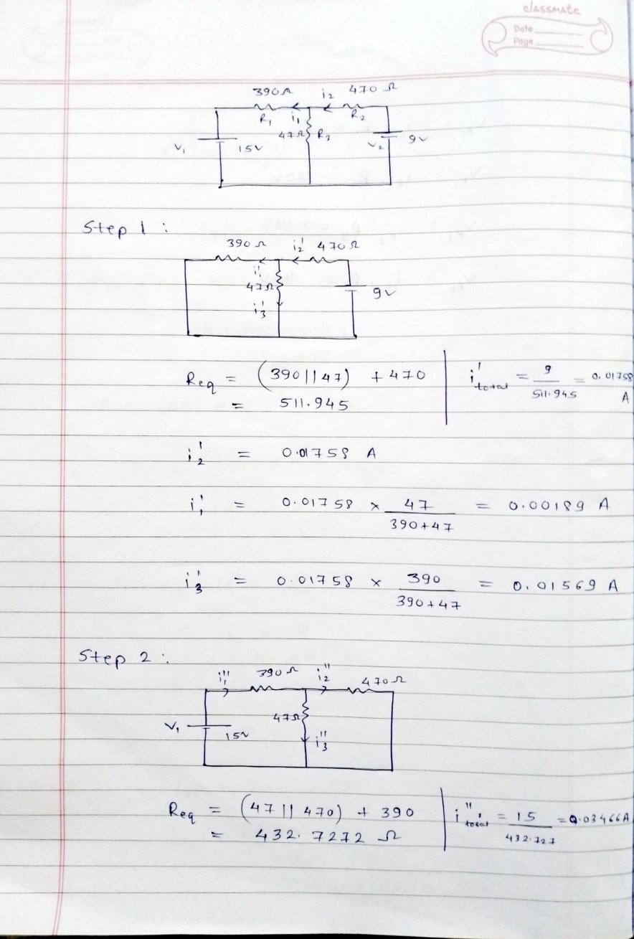

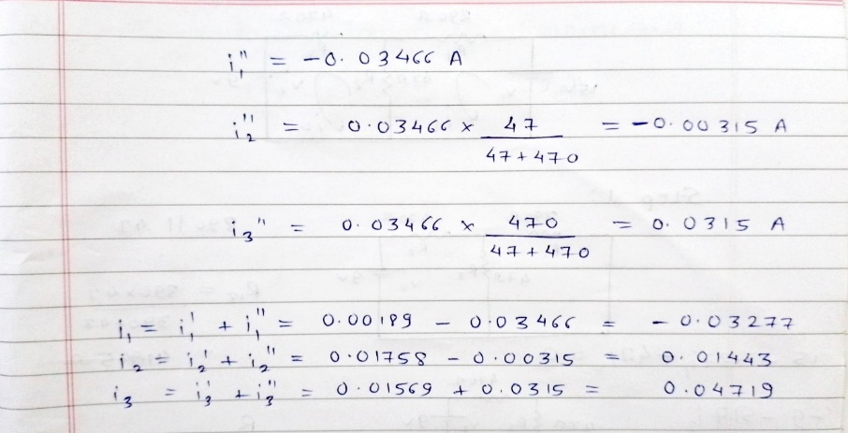

**RESULT TABLE:**

|  |  |  |  |  |  |  |  |  |  |  |
| --- | --- | --- | --- | --- | --- | --- | --- | --- | --- | --- |
| **V1 (V)** | **V2 (V)** | **Current through R1 (A)** | | | **Current through R2 (A)** | | | **Current through R3 (A)** | | |
|  |  | **Theoretical** | **Observed** | **By Simulation** | **Theoretical** | **Observed** | **By Simulation** | **Theoretical** | **Observed** | **By Simulation** |
| **15** | **-** | -0.03466 | -0.032 | -0.0346 | -0.00315 | -0.0032 | -0.00315 | 0.0315 | 0.031 | 0.03151 |
| **-** | **9** | 0.00189 | 0.002 | 0.00189 | 0.01758 | 0.017 | 0.01758 | 0.01569 | 0.016 | 0.01569 |
| **15** | **9** | -0.03277 | -0.03 | 0.03277 | 0.01443 | 0.014 | 0.01443 | 0.04719 | 0.047 | 0.0472 |

**CONCLUSION:**

